**Manual Test Plan**

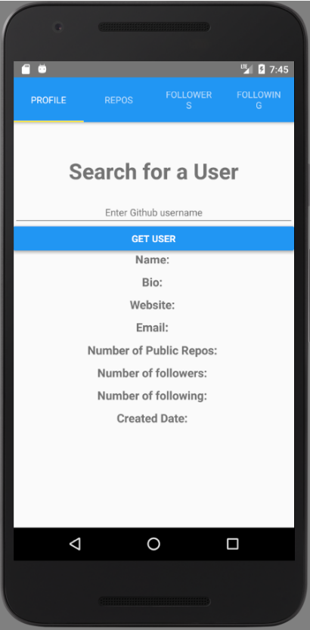Starting up your app

Upon start, your app will look as shown in the screenshot to the left. You will start on the left-most tab called “Profile” where you can search for Github Users by their username.

There will be an empty input box, and a “Get User” button to click when searching. Below the button are empty fields for each user that will later be filled when searching for a user.

Searching for a user

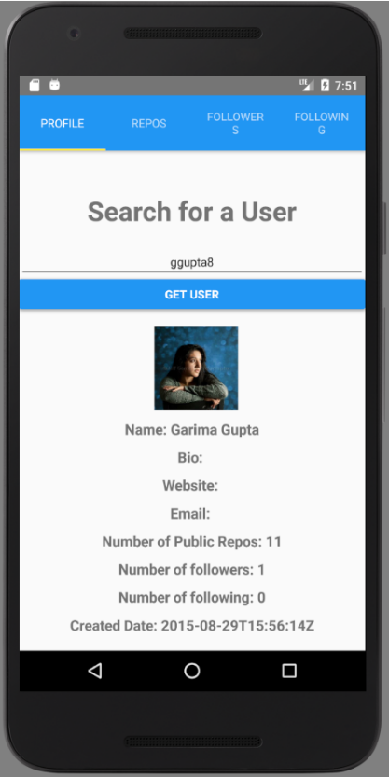

Once you search for a user, if they exist, you will see that user’s information be filled in the corresponding fields. If there is no information to be found, the field will remain blank/empty.

When clicking on the avatar image, a new window in your browser will open up to the user’s profile’s link.

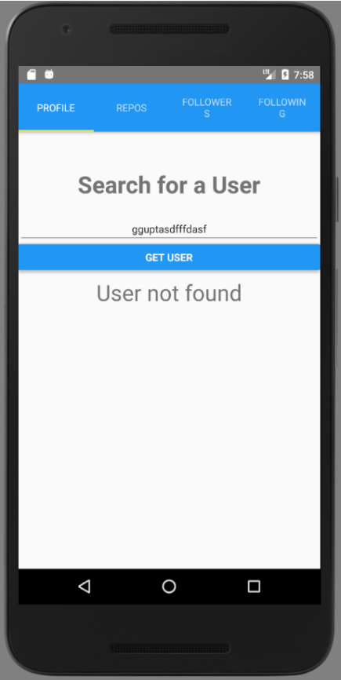

If there is no user to be found, the message “User not found” will display.

Searching for repositories

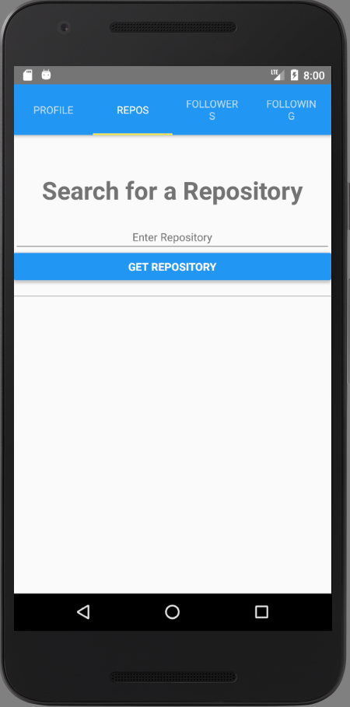

You can also search for repositories by clicking on the “Repos” tab at the top of the screen. As with the “Profile” screen, you will see an input textbox to enter the repository and a button to click when searching.

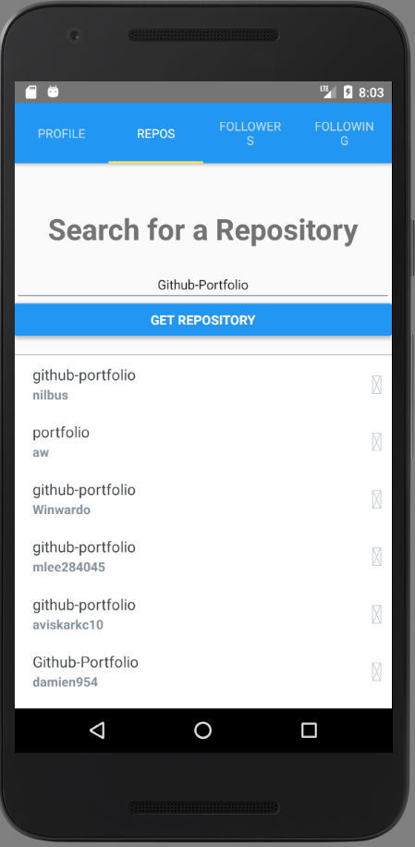

When searching for a repository, a list of repositories with matching keywords will be displayed. You can scroll down the list by dragging your finger upwards.

You can click on each repository to open a new link to the repository in your browser.

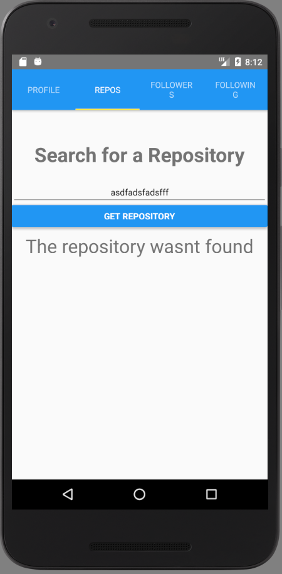

If there is no repository to be found, the message “The repository wasn’t found” will display.